This level is similar to Level 2. It aims to show “turnLeft” function and a new condition that shortens otherwise long code. In programs, as in every aspect of your life, you must be as efficient as you possibly can. Best software is fastest because of good programing practices. For this reason, programmers use functions that are already pre-defined in libraries. This allows them to code less and have best functioning statement in the application.

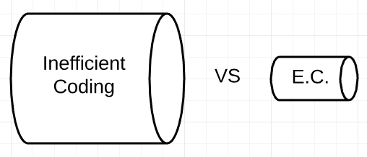In our game, we tried to show that aspect by implementing “general” loop condition that allows to avoid repetition in the code. Not only this is more readable, but also quicker to drag&drop.

Additionally, this level allows the user to have loop inside of another loop. We intended to show that sometimes efficiency is achieved by using complex algorithms; this will take away repetition, but requires deeper thinking and some assumptions as well as predictions made about future execution of the code.

Figure 1: Efficient coding

Interestingly, efficient algorithms are used to save data on your computer. So, for example, there are many ways in which a picture or a song can be stored taking less memory but remaining lossless (that is losing no data). Computer scientists all over the world compete to create best algorithms. Just imagine Blue Ray movie that weights 1 MB – takes about 2 seconds to download. Not only it allows you to store more precious files on your laptop, but also saves traffic, and so money.